Leader Guide

Educator Insider Series:

Facilitated Learning Workshops
Introducing Microsoft 365 Features to Support Remote and Hybrid Learning
Contents
Overview 2
Length 2
Background 2
Target audience 2
Learning goals 2
Required leader preparation 2
Advance preparation 2
Day-of preparation 2
Required skills 3
Recommended resources 3
Best practices for leading an inclusive, accessible workshop 3
Technical support 4
Outline 5
Introduction and overview (5 minutes) 5
Applications (4 minutes) 5
PowerPoint Expanded (9 minutes) 5
Word Enhanced (8 minutes) 5
OneNote – A Digital Trapper Keeper (7 minutes) 5
Conclusion (2 minutes) 6
Demonstration Instructions 6
Demonstration 1: Waffle (Slide 7) 6
Demonstration 2: PowerPoint Live (Slide 9) 7
Demonstration 3: PowerPoint Designer (Slide 10) 8
Demonstration 4: Immersive Reader in Word Online (Slide 12) 9
Demonstration 5: Dictation in Word Online (Slide 12) 9
Demonstration 6: Create a new notebook (Slide 15) 9

Overview

Length
Approximately 30 minutes plus Q&A

Background
The workshops in this series are modeled after “real-life” remote classes, with participants walking through a similar learning journey and engaging in similar activities as the K-12 student. We designed it this way so that participants experience how Microsoft tools may be used in the digital classroom. This may also help participants gain a better understanding of teacher expectations. Our goal is to equip parents and families with the practical knowledge and skills to better support their student’s education.

Target audience
This course will target parents, families and caregivers supporting their student in remote or hybrid learning. The course is designed for participants who would like to learn more about different programs that can be used to support student learning.

Learning goals
After completing this workshop, participants will be able to:
- Identify applications that are a part of Microsoft 365 and how these applications make work more efficient.
- Utilize Immersive Reader and Dictation in Word.
- Identify and utilize features of PowerPoint such as Live and Designer.
- Identify elements of OneNote that make it useful for students, educators, and parents.

Required leader preparation

Advance preparation
To prepare for the workshop:
- Review the suggested scripting in the PowerPoint slide notes.
- Make sure that you have a Teams for Education demo account.
- Practice your presentation in Slide Show mode.
- Practice all demonstrations (see Required skills).
- Update slides [slide numbers] with required store-specific information (or hide them).

Day-of preparation
Before the workshop begins:
- Ensure that you have access to a Teams for Education demo account and the PowerPoint.
- Digital version of the participant guide.
Your presentation device and the community devices should have up-to-date versions of Windows 10 and Microsoft Office. Specific requirements are listed below.
 | For the leader | For participants
Hardware | Surface Pro or Windows 10 PC  Surface Pen  Screen display and connecting cables | Their own PC  Internet access
Software | Microsoft Teams  Microsoft Word  Microsoft PowerPoint  Forms | Microsoft Teams
Materials | Leader guide  PowerPoint presentation | Participant guide (digital)

Required skills
To perform the demonstrations in this workshop successfully, you need to be able to:
- Explain and demonstrate Microsoft Teams
- Explain and demonstrate how to use PowerPoint
- Explain and demonstrate how to use OneNote
- Demonstrate how to take an assessment in Forms

"Note: As Microsoft products are ever-evolving, app features and user interface elements referenced in this workshop’s materials may change over time as updates are released. Please understand that the provided demo and activity instructions reflect features and UI current at the time of publishing—be sure to practice and adjust as needed.”

Recommended resources
For additional support, review the following resources:
- Teams for Education demo account
- Microsoft Forms
- Microsoft PowerPoint
- Microsoft Word
- For help preparing to give an effective presentation, rehearse your slide show with Presentation Coach.

Best practices for leading an inclusive, accessible workshop

Setup considerations
- Use the Subtitles feature in PowerPoint to caption your presentation in real time.
- To create an autism-friendly environment, limit visual and auditory sensory input in the store.

Language to use and avoid
- Microsoft recommends people-first language. Use the “people with/who + disability” equation. For example: person with a disability, who is blind, or who uses a wheelchair.
- Avoid insensitive describing words.
- Practice empowerment, promote strong role models, and don’t condescend to people with disabilities. For example, don’t portray people with disabilities as inspirational just because they have a disability.

Facilitation tips
- Always ask if you can help, then wait until your help is accepted before you do anything.
- Speak directly to the person you’re addressing rather than to a companion or interpreter.
- When speaking, make sure your mouth is in full view of participants in case they read lips.
- If you are corrected by someone or make a mistake, accept it, ask for suggestions to fix it, and move on.
For more information, refer to any additional accessibility training materials provided to your store, if available.

Technical support
For technical issues with community devices, open a Think Time ticket detailing the issue. You can expect a response within one business day.

Outline
Consider using this outline as a checklist while conducting the workshop. Times are suggestions. The following is an example outline for a thirty-minute workshop. Adjust timings and add content as appropriate.

Introduction and overview (5 minutes)
Slides | Topic | Time | Description
Slides 1-2 | Hidden tips | N/A | Hidden instruction slides summarizing essential prep and info.
Slide 3 | Opening | 1 min | Welcome participants and introduce workshop staff. Present Microsoft Forms Poll
Slide 4 | Overview  Video | 3 min | Provide an overview of the workshop’s agenda and activities  Microsoft 365 Video
Slide 5 | Learning Objectives | 1 min | Provide an overview of the learning objectives for the course

Applications (4 minutes)
Slides | Topic | Time | Description
Slide 6 | Introduction | 1 min | Overview of Microsoft 365
Slide 7 | Demonstration | 3 min | Demonstration of how to navigate Microsoft 365

PowerPoint Expanded (9 minutes)
Slides | Topic | Time | Description
Slide 8 | Introduction  Activity | 1 min | Overview of the features
Slide 9 | Demonstration | 4 min | Demonstrate how to use PowerPoint Live
Slide 10 | Demonstration | 4 min | Demonstrate how to use PowerPoint Designer

Word Enhanced (8 minutes)
Slides | Topic | Time | Description
Slide 11 | Introduction | 1 min | Overview of Word
Slide 12 | Demonstration | 3 min | Demonstrate how to use Immersive Reader  Demonstrate how to use Enhanced Dictation
Slide 13 | Activity | 1 min | Microsoft Whiteboard Activity

OneNote – A Digital Trapper Keeper (7 minutes)
Slides | Topic | Time | Description
Slide 14 | Intro | 2 min | Overview of OneNote
Slide 16 | Demonstration | 5 min | Demonstrate OneNote features

Conclusion (2 minutes)
Slides | Topic | Time | Description
Slide 16 | Wrap-up  Forms survey | 2 min | Conclusion, Forms
Slide 17 | QA |  | Question and Answer

Demonstration Instructions

Demonstration 1: Waffle (Slide 7)

Key points to communicate
- The waffle is very easy to use to navigate applications in Microsoft 365

Step-by-step instructions

Step 1: Demonstrate that the Microsoft 365 app launcher (waffle) is a menu of apps and services that you have available when you select the waffle on Office.com. The waffle makes it very easy to open and switch between apps.

Step 2: Demonstrate how the waffle also gives you quick access to your most recent online Office documents.

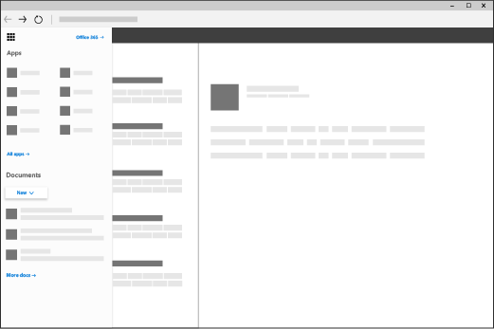

Demonstration 2: PowerPoint Live (Slide 9)

Key points to communicate
- PowerPoint Live can be used to communicate with the audience in multiple languages

Step-by-step instructions
Step 1: Since you are presenting using Microsoft Teams you will need to use screen sharing mode rather than presentation sharing mode. State to the audience that if they would like to see the feature in action then they may need to use a separate device which will allow the primary device to be dedicated to the presentation itself.
Step 2: To get started with Live Presentations open your slide deck in PowerPoint for the web and go to the Slide Show tab. First, check your audience setting. Click the drop arrow next to Present Live to select who should be able to connect to this presentation. Depending on who you are presenting to you can either select Only people in your organization or Anyone.
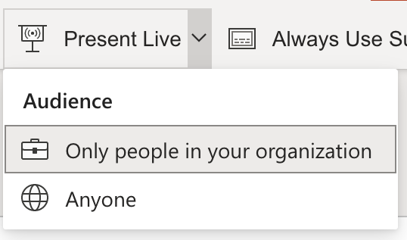
Step 3: select Present Live and your presentation will begin with a screen that shows a customized QR code. You can also start your Live presentation from the slideshow toolbar. Explain that the audience can point their device cameras at the QR code, tap the link that appears over the QR code and then PowerPoint Live will load the presentation into their web browsers.

Step 4: Explain that once the presentation is loaded then they will see your spoken words transcribed on the screen in near real-time. If an audience member would like to have your words translated for them into a different language, they can tap the language indicator and select from one of more than 60 other languages. Once they've selected their language your spoken words will be machine translated into that language, and shown to them on their device as subtitles.
Step 5: If someone wants to give you feedback as you go they can tap the feedback button (which looks like a smiley face) towards the bottom right of their device screen. There they can select from a handful of different feedback types, from "like" to "puzzled" and more. Their selection will briefly appear on the presentation screen.

Demonstration 3: PowerPoint Designer (Slide 10)

Key points to communicate
- PowerPoint Designer can make creating presentations very easy through the use of artificial intelligence.

Step-by-step instructions
Step 1: Using a preloaded PowerPoint demonstrate how to use PowerPoint Designer. Explain to the audience that they can ask for design ideas any time by choosing Design > Design Ideas on the ribbon.
Step 2: Explain that this is an additional feature for subscribers. The first time you try out PowerPoint Designer, it asks your permission to get design ideas for you. If you want to use Designer, select Turn on or Let's go. Once you've turned on intelligent services, PowerPoint automatically shows you design ideas when you add photos to your slides.
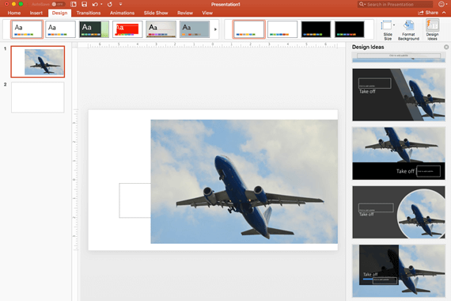
Step 3: Scroll through the suggestions in the Design Ideas pane on the right side of the window. Click to select the design you want, or else close the window. Explain that if you select one of the ideas, your slide is changed accordingly. You can also select another idea from the pane or go back to your original slide design: Press ⌘+Z to undo a design change you've just selected. You can ask for design ideas any time by choosing Design > Design Ideas on the ribbon.
Step 4: PowerPoint Designer gives the user suggestions Professional Layouts, SmartArt graphics, Illustrations.

Demonstration 4: Immersive Reader in Word Online (Slide 12)

Key points to communicate
- Immersive Reader is a tool that can help anyone who needs help with larger texts or increasing their fluency.

Step-by-step instructions
Step 1: Open the preloaded document. When you have the document open, select View and then Immersive Reader.

Step 2: Demonstrate using the sample text in the preloaded document that you can have the text read aloud to you or you can also select individual words to be pronounced in English or in any of the languages included.

Demonstration 5: Dictation in Word Online (Slide 12)

Key points to communicate
- Dictation is a tool that can help students save time with writing papers.

Step-by-step instructions
Step 1: Open a blank document. Go to Home > Dictate.

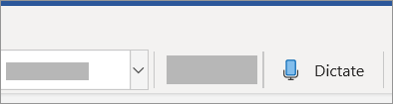

Step 2: When the mic icon appears make sure that the participants know to wait for it to turn on to be sure it has started listening.

Step 3: Demonstrate Dictation by saying the following sentences or sentences of your choice. “I like going to the market so that I all can buy all kinds of foods! Would you like to go to the market with me?” You can use these sentences to demonstrate how to include punctuation marks. You include them by actual saying the name i.e. exclamation mark.

Demonstration 6: Create a new notebook (Slide 15)

Key points to communicate
- OneNote makes it very easy to create, store and organize notes.

Step-by-step instructions

Step 1: On any page, click the Show Notebooks button . At the bottom of the pane that appears, click + Notebook. Enter a name for the new notebook, and then click Create Notebook. OneNote switches to the new notebook, which contains a new section and a new, blank page.
Step 2: Demonstrate that there are several different ways to take notes. Demonstrate one of the following. 1. Click or tap the page header at the top of the page (over the date and time stamp) to type a page title. 2. Click or tap anywhere on the current page and start typing. 3. Click or tap anywhere else on the same page to begin a new note and then start typing. 4. Use either the pen or stylus that came with your device to handwrite notes directly on a touchscreen. If you want to use your finger to draw or write, click the Draw tab, and then click or tap the Draw with Mouse or Touch icon.
Step 3: OneNote also allows you to insert pictures and videos. On any page, tap where you want to insert a picture. On the Home tab, click or tap Camera. Allow OneNote to use your camera. When the live image appears in your camera, tap the screen to take the picture. Click or tap Insert All to insert the captured picture (or pictures).

